PSSI Science Project Reporting Template

️ | The PSSI Implementation Team is compiling a technical report to demonstrate the important research and advancements made by the Science Branch through the PSSI funding. The technical report will include a 3-4 page summary (including graphics and figures) for each project to show their key results and findings. Please fill in the following fields and sections for your project to be included in the report. Feel free to include and draw from any reports or presentations previously created through your research.  A plain language science bulletin will also be created to follow up on last year’s “DFO Pacific Region Science Bulletin, 2024. New research and monitoring for Pacific salmon and their ecosystems.” While the first bulletin introduced project backgrounds, methods, and timelines, this new bulletin will highlight the projects’ results, key findings, and conclusions with links to reports and data available. The bulletin will include a 1-2 page summary for each project gleaned from the content entered below.  ️ Completed forms are due January 7, 2026.  *Please include or send separately any graphics or pictures (with photo credits) that will help promote the projects.

PART 1: PROJECT METADATA

General Project Information
Project ID (number) | Project Title
2432 | Barkley Sound acoustic monitoring of salmon and salmon prey
Project Leads | Collaborations and External Partners
Stéphane Gauthier | Follow the Fish team
Location (if applicable) | Follow the Fish team
WCVI, Barkley Sound | Follow the Fish team

Geographic and Stock Information
Salmon species (if applicable) | Waterbodies (if applicable)
Click or tap here to enter text. | Click or tap here to enter text.
Life history phases (if applicable) | Region
juvenile | West Coast Vancouver Island
Stock (if applicable) | Population (if applicable)
Click or tap here to enter text. | Click or tap here to enter text.
Conservation Unit (if applicable)
Click or tap here to enter text.

🧰 PART 2: PROJECT METRICS

Project Outputs
Include any anticipated outputs denoted as (in progress). Please include links to any outputs available online so they can be referenced in the report.
List scientific publications and technical reports (with links)
Linking oceanic variability, euphausiid hotspot persistence and marine predator distribution along the Pacific coast of Canada. 2026. Evans, R. Gauthier, S., Robinson, C.L.K., English, P.A., Stanley, C., Wright, B.M., Nichol, L. Ecological Application 2026;36:e70141. https://doi.org/10.1002/eap.70141

List datasets generated (with links)
Active Acoustic Data
Describe dataset locations and data management systems
Active Acoustic Data archived at the Institute of Ocean Sciences, following National Acoustic Data Archive protocols and ICES metadata standards.

List code, programs, or other software created (with links)
Click or tap here to enter text.
List communication or social media products
Follow the Fish – presentation at the ICES Working Group on Fisheries Acoustics, Science and Technology, April 2025, Rekjavik, Iceland

Fisheries Acoustics as a tool to monitor Salmon, Salmon prey, and Salmon predation – presentation to the Maa-nulth JFC, January 2026.

List and describe field work completed
Deployments and retrievals of 4 autonomous echosounder moorings off the West Coast of Vancouver Island (fieldwork from the Bamfield Marine Science Center).

List and describe samples collected/analyzed (number of samples)
Over 30,000 hours of continuous data recording from autonomous echosounders
List and describe large capital assets or equipment acquired
Replacement of 1 autonomous echosounder mooring (system damaged and lost due to water ingress following deployment in Clayoquot Sound).

PART 3: WRITTEN CONTENT

Highlights
Please summarize in 2-3 bullets:
- The main idea of the project
- Key findings
- Implications of these findings for salmon and decision-makers
- For a more technical audience, but still as plain language as possible
- Large scale acoustic surveys off the BC coast revealed persistent euphausiids hotspots – such data (along with further work on forage species) could ultimately inform on conditions critical for adult salmon marine survival.
- Fine temporal scale monitoring in nearshore coastal areas of Barkley Sound revealed year-long habitat use by juvenile salmon, with clear pulses in late Summer and early Fall.
- These juvenile salmon densities are linked to densities and availability of euphausiids.
- Competition and predation pressures from other fish species (Pacific herring and demersal predators like walleye pollock/Pacific hake) are present year-round and are found near surface water at night (co-occurring with juvenile salmon). Predation events from birds/marine mammals have been recorded multiple times at these sites, and did not appear to be density dependent.

Background
Please provide 1-2 paragraphs to summarize
- The relevant biological, environmental, and/or management context
- What knowledge gap or demand were you trying to fill?
- Collaboration and partner relationships
Fisheries acoustics can be used to answer a number of questions related to Salmon ecology and dynamics. On large spatial scales, acoustic surveys are used to assess salmon prey (e.g forage fish and krill) conditions along the BC coast, identify prey hotspots, and assess changes in productivity through time. On a finer temporal scale, moored autonomous echosounders can provide information on juvenile salmon coastal habitat use, in conjunction with prey availability and predation pressures.

Autonomous echosounder system were used to address key elements affecting juvenile salmon during the first stage of marine life, including the timing of juvenile salmon use of coastal areas (time spent in key areas and within the water column), the prey conditions (e.g. euphausiids dynamic) they encounter in these areas, and the competition and predation pressures that affect them.

️ Methods and Findings
Please insert a few paragraphs to summarize:
- Main methods used
- Products and tools produced
- Advancements in methodology, technology, and application
- Advancements in communication and knowledge transfer
- Key results and information generated
We used active acoustics methods as a remote sensing tools to assess the salmonsphere (salmon as well as their prey and predators). Large scale fisheries acoustic surveys conducted along the BC coast over the continental shelf and slope are used to assess marine conditions and the abundance and distribution of key prey species for adult Chinook salmon (e.g. Pacific herring and euphausiids). On a finer temporal scale, we used moored inverted echosounders to monitor juvenile salmons (and salmonsphere ecosystem components) in coastal areas within Barkley Sound.

Two autonomous systems were moored on the bottom of Barkley Sound nearshore areas with the transducers facing upward toward the sea surface, detecting juvenile salmon and all marine organisms as they go through the acoustic beam. Previous work in coastal areas using direct sampling methods (e.g. purse seine) combined with such moorings, as well as libraries of acoustic-trawl surveys and frequency-based signal processing techniques is enabling the classification of acoustic backscatter into species group (juvenile salmon, Pacific herring, walleye pollock and similar demersal fish, euphausiids) to obtain fine scale temporal data on their prevalence and relationship over more than a year of continuous data collection. In addition, surface predation events (from diving birds and/or marine mammals) are documented for the entire time-series. Acoustic methods are not capable of identifying juvenile salmon to species. To achieve species-specific interpretations the data will rely on other available sampling and ancillary data (seine, micro-trolling, eDNA, hatchery release timing) to further partition the acoustic information that was attributed to juvenile salmon.

Insights
Please insert a few paragraphs to summarize:
- What this project has added to knowledge about salmon populations, health, or ecosystems.
- How this project informs salmon management:
  - decisions
  - policy guidance
  - trade-offs
  - planning
- Addition of knowledge to understanding:
  - limiting factors/stressors/threats/ pathways of effects/risks
  - biologically significant thresholds
  - cumulative impacts
- Sources of uncertainty
- Large spatial scale acoustic data have revealed persistent hotspots of euphausiids (a key salmon prey) along the BC coast – expansion of this work will include key forage fish species.

- Moorings in nearshore coastal areas of Barkley Sound reveal the presence of juvenile salmon year-round, but having a clear pulse of activity and density in Late summer-early Fall. Although juvenile salmon have been detected throughout the top 50 m of the water column, they predominantly occupy the top 15-20 m of the water surface.

- Pulses of juvenile salmon were closely linked to the availability and density of a key prey, euphausiids (krill). Krill display distinct diel vertical migrations (prey are at depth during the day and near surface at night).

- Key competitors (Pacific herring) and fish predators (walleye pollock and/or Pacific hake) are present throughout the year, and also exhibit diel migration (mixing with juvenile salmon in the surface layer at night).

- Further predation pressure from birds and/or marine mammals were identified throughout the time-series (documented daytime surface attacks), and does not appear to be density dependent, with many events occurring in the Winter when fewer surface schools are observed.

⏩ Next Steps
Please insert 1-2 paragraphs to summarize:
- Remaining knowledge gaps and recommendations for future studies
- How can/should the project findings be operationalized for salmon conservation and management?
This study was implemented in the second year of PSSI. Acoustic data collected from moored systems are only available once instruments are recovered, in as such, we are just finalizing the processing and analyses of these acoustic data – integration with other sampling (micro-trolling, eDNA, etc) that occurred while the instrument were collecting data will be a critical step to fully interpret these data and publish the findings.

📈 Tables and Figures
Please provide captions and numbering for any tables and figures. Graphics can be copied below or e-mailed separately.
- Include a brief caption with each figure and table in the box below
- Number each table and figure, and include references in the above sections where appropriate.
- 1-3 figures are recommended per project
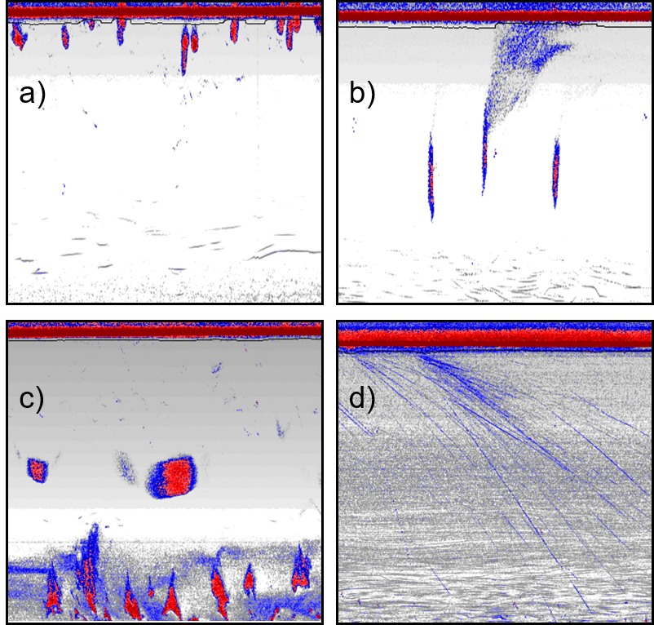
Figure 1. Typical echogram observed in Barkley Sound, where the top red band indicate the water surface, total depth displayed is around 80 m. a) dense juvenile salmon schools near the surface, b) typical herring schools, with one displaying the release of gas bubbles, c) demersal fish schools (likely walleye pollock within the deeper krill layer, d) example of a surface predation event, showing multiple animals/fish diving deep.

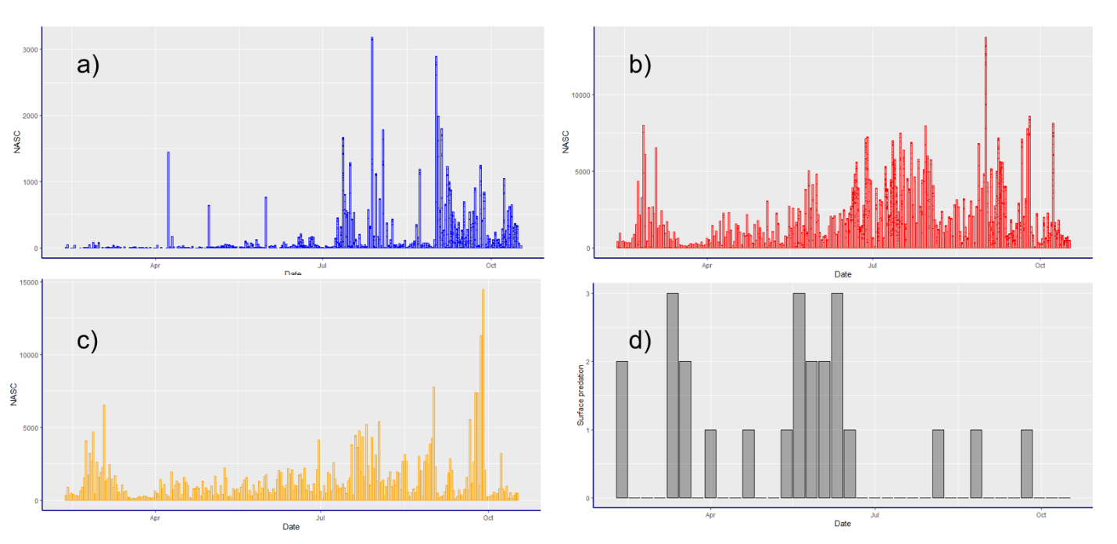
Figure 2. Time series of the Mackenzie Anchorage mooring site in Barkley Sound (only including first deployment from February to October 2024): a) juvenile salmon, b) Pacific herring, c) walleye pollock, d) detected surface predation events from diving birds/marine mammals.

📈 References
Include full references for any publications referenced in other sections. Please format references in Harvard style according to Instructions to Authors for the Canadian Journal of Fisheries and Aquatic Sciences, at Canadian Science Publishing.
Click or tap here to enter text.

